DEEP LEARNING
UNIT-1
TOPICS: Historical Trends in Deep Learning, McCulloch Pitts Neuron, Thresholding Logic, Perceptrons, Perceptron Learning Algorithm, Representation Power of MLPs, Sigmoid Neurons, Gradient Descent, Feed forward Neural Networks. Back propagation algorithm.

DEEP LEARNING:
Deep Learning is transforming the way machines understand, learn and interact with complex data. Deep learning mimics neural networks of the human brain, it enables computers to autonomously uncover patterns and make informed decisions from vast amounts of unstructured data.
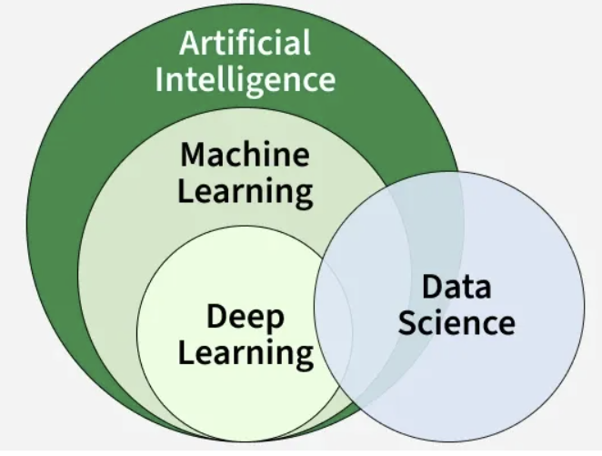
Neural Networks:
Neural networks are machine learning models that mimic the complex functions of the human brain. These models consist of interconnected nodes or neurons that process data, learn patterns and enable tasks such as pattern recognition and decision-making.
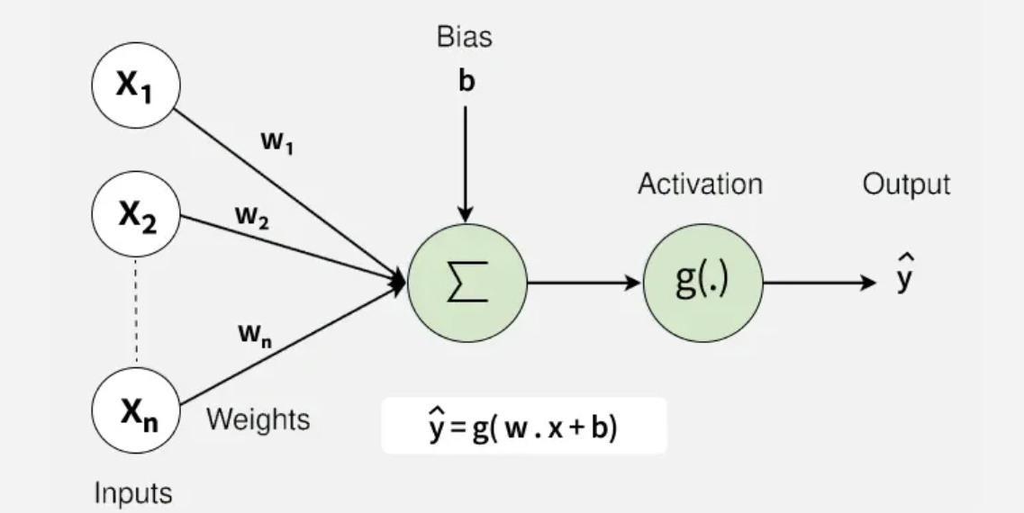
FIG-1: Neural Network
These networks are built from several key components:
- Neurons: The basic units that receive inputs, each neuron is governed by a threshold and an activation function.
- Connections: Links between neurons that carry information, regulated by weights and biases.
- Weights and Biases: These parameters determine the strength and influence of connections.
- Propagation Functions: Mechanisms that help process and transfer data across layers of neurons.
- Learning Rule: The method that adjusts weights and biases over time to improve accuracy.
Layers in Neural Network Architecture:
- Input Layer: This is where the network receives its input data. Each input neuron in the layer corresponds to a feature in the input data.
- Hidden Layers: These layers perform most of the computational heavy lifting. A neural network can have one or multiple hidden layers. Each layer consists of units (neurons) that transform the inputs into something that the output layer can use.
- Output Layer: The final layer produces the output of the model. The format of these outputs varies depending on the specific task like classification, regression.
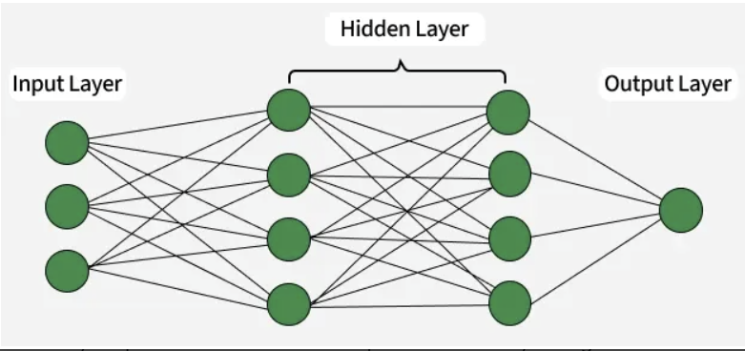
FIG-2: Neural Network Architecture

Working of Neural Networks:
1. Forward Propagation:
When data is input into the network, it passes through the network in the forward direction, from the input layer through the hidden layers to the output layer. This process is known as forward propagation. Here’s what happens during this phase:
1.1 Linear Transformation: Each neuron in a layer receives inputs which are multiplied by the weights associated with the connections. These products are summed together and a bias is added to the sum. This can be represented mathematically as:
$$z=w_{1}x_{1}+w_{2}x_{2}+…+w_{n}x_{n}+b$$
Where:
- $w$ represents the weights
- $x$ represents the inputs
- $b$ is the bias
1.2 Activation: The result of the linear transformation (denoted as $z$) is then passed through an activation function. The activation function is crucial because it introduces non-linearity into the system, enabling the network to learn more complex patterns. Popular activation functions include ReLU, sigmoid and tanh.
2. Backpropagation:
After forward propagation, the network evaluates its performance using a loss function which measures the difference between the actual output and the predicted output. The goal of training is to minimize this loss. This is where backpropagation comes into play:
- Loss Calculation: The network calculates the loss which provides a measure of error in the predictions. The loss function could vary; common choices are mean squared error for regression tasks or cross-entropy loss for classification.
- Gradient Calculation: The network computes the gradients of the loss function with respect to each weight and bias in the network. This involves applying the chain rule of calculus to find out how much each part of the output error can be attributed to each weight and bias.
- Weight Update: Once the gradients are calculated, the weights and biases are updated using an optimization algorithm like stochastic gradient descent (SGD). The weights are adjusted in the opposite direction of the gradient to minimize the loss. The size of the step taken in each update is determined by the learning rate.
3. Iteration:
This process of forward propagation, loss calculation, backpropagation and weight update is repeated for many iterations over the dataset. Over time, this iterative process reduces the loss and the network's predictions become more accurate.
Through these steps, neural networks can adapt their parameters to better approximate the relationships in the data, thereby improving their performance on tasks such as classification, regression or any other predictive modeling.
Types of Neural Networks:
- Feedforward neural networks (FNNs): They are the simplest type of ANN, where data flows in one direction from input to output. It is used for basic tasks like classification.
- Convolutional Neural Networks (CNNs): They are specialized for processing grid-like data, such as images. CNNs use convolutional layers to detect spatial hierarchies, making them ideal for computer vision tasks.
- Recurrent Neural Networks (RNNs): They are able to process sequential data, such as time series and natural language. RNNs have loops to retain information over time, enabling applications like language modeling and speech recognition. Variants like LSTMs and GRUs address vanishing gradient issues.
- Generative Adversarial Networks (GANs): This consist of two networks—a generator and a discriminator—that compete to create realistic data. GANs are widely used for image generation, style transfer and data augmentation.
- Autoencoders: They are unsupervised networks that learn efficient data encodings. They compress input data into a latent representation and reconstruct it, useful for dimensionality reduction and anomaly detection.
- Transformer Networks: It has revolutionized NLP with self-attention mechanisms. Transformers excel at tasks like translation, text generation and sentiment analysis, powering models like GPT and BERT.

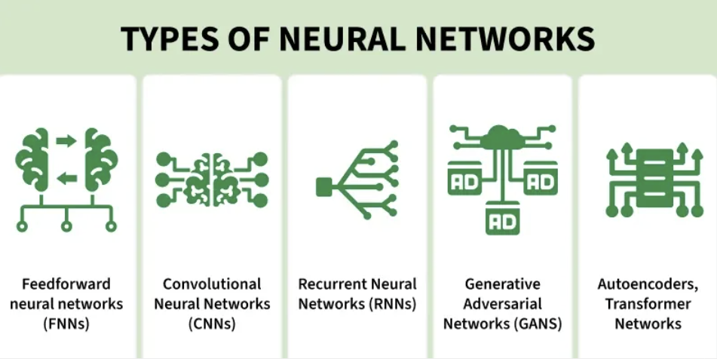
FIG -3: Types of Neural Networks:

Historical Trends in Deep Learning:
“Deep learning did not suddenly appear in 2012. It is the result of nearly 70 years of ideas, failures, rebranding, and technological evolution.”To understand why deep learning works today, it is necessary to understand why it failed earlier and what has changed over time. Goodfellow does not describe deep learning as a miracle, but as an inevitable outcome of progress in three critical areas:
• Availability of large datasets
• Advances in computational power
• Development of better training algorithms
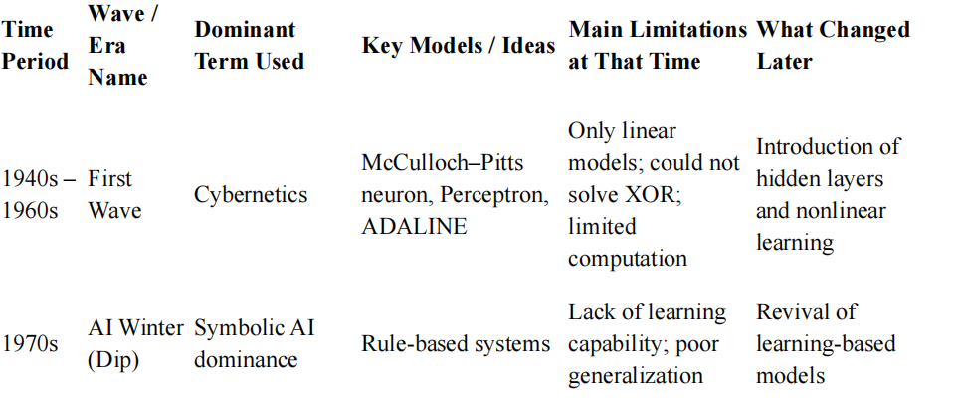
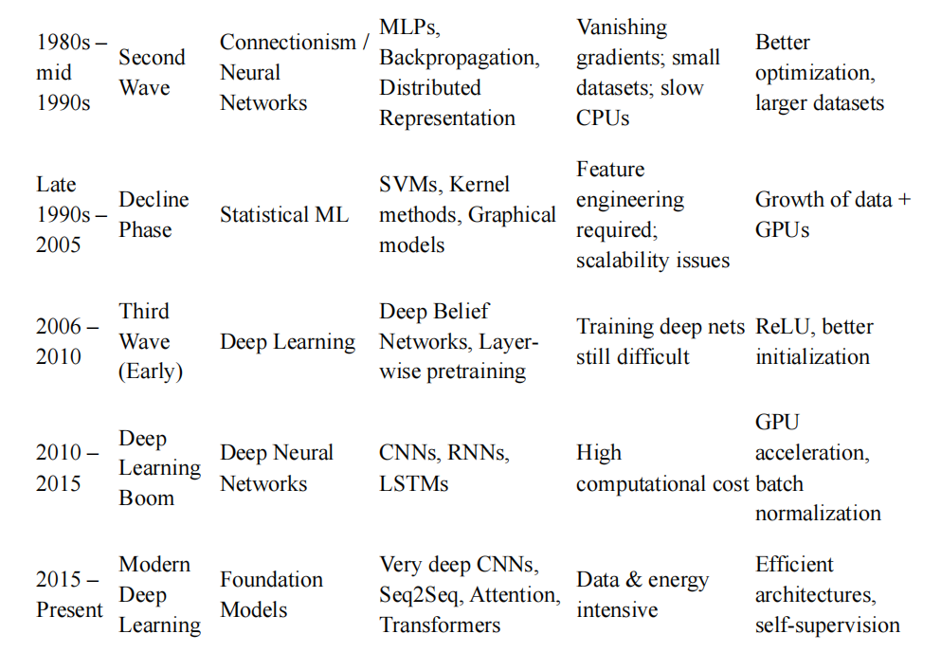
McCulloch Pitts Neuron:
The McCulloch–Pitts neuron is one of the earliest and simplest mathematical models of a biological neuron. Proposed in 1943 by Warren McCulloch and Walter Pitts, it laid the foundation for artificial neural networks and logical computation using neurons.
The MP neuron performs a binary classification based on a weighted sum of inputs and a fixed threshold.
Key Properties
• Binary inputs: 𝑥𝑖 ∈ {0,1}
• Binary output: 𝑦 ∈ {0,1}
• Fixed threshold: 𝜃(theta) is constant
• No learning: Weights are predefined
• No bias term
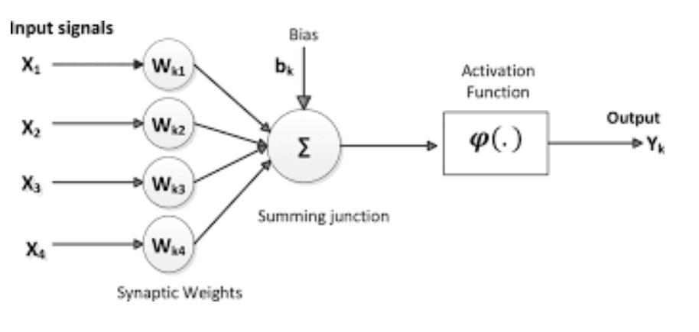
Mathematical Model
Input Representation
x = [𝑥1, 𝑥2, 𝑥3, … , 𝑥𝑛] 𝑇
Where:
• 𝑥𝑖 ∈ {0,1}: Binary input (0 = absent, 1 = present)
• 𝑛: Number of inputs
• 𝑇: Transpose (column vector)
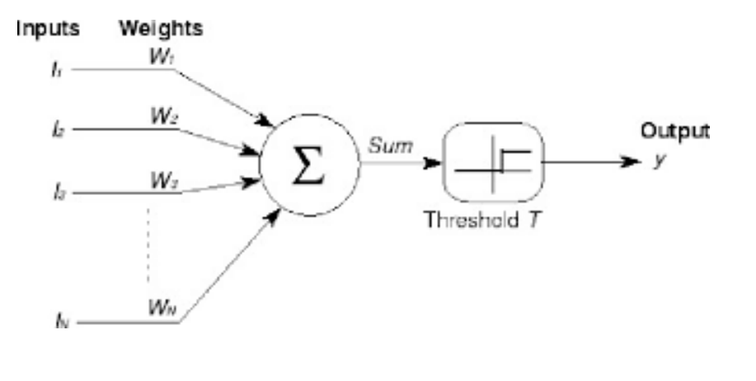
Weight Vector :
w = [𝑤1, 𝑤2, 𝑤3, … , 𝑤𝑛] 𝑇
Where:
• 𝑤𝑖 ∈ ℝ: Weight for i-th input
• 𝑤𝑖 > 0: Excitatory connection
• 𝑤𝑖 < 0: Inhibitory connection
Aggregation Function (Net Input)
𝑛
Net = ∑𝑤𝑖 𝑥𝑖 = 𝑤1𝑥1 + 𝑤2𝑥2 + ⋯ + 𝑤𝑛𝑥𝑛
𝑖=1
Symbol Explanation
• Net: Total weighted input (scalar value)
• Σ (capital sigma): Summation operator
• 𝑖 = 1to 𝑛: Index runs from 1 to n
Function (Activation):
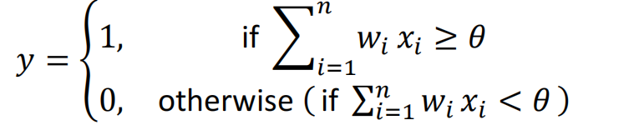
This mechanism is called Thresholding Logic.

Example:
MP Neuron for Truth Table (AND Gate):
X1 | X2 | Y(AND)
0 | 0 | 0
0 | 1 | 0
1 | 0 | 0
1 | 1 | 1

MP Neuron Configuration
• Weights: 𝑤1 = 1, 𝑤2 = 1
• Threshold: 𝜃 = 2
Verification
Case 1: 𝑥1 = 0, 𝑥2= 0
Net = 1(0) + 1(0) = 0 < 2 ⇒ 𝑦 = 0✓
Case 2: 𝑥1 = 0, 𝑥2 = 1
Net = 1(0) + 1(1) = 1 < 2 ⇒ 𝑦 = 0✓
Case 3: 𝑥1 = 1, 𝑥2 = 0
Net = 1(1) + 1(0) = 1 < 2 ⇒ 𝑦 = 0✓
Case 4: 𝑥1 = 1, 𝑥2 = 1
Net = 1(1) + 1(1) = 2 ≥ 2 ⇒ 𝑦 = 1✓

Thresholding Logic:

